Module 2 : CSS and CSS 3

Que) What are the benefits of using CSS?

Ans) CSS handles the look and feel part of a web page. Using CSS, you can control the color of the text, the style of fonts, the spacing between paragraphs, how columns are sized and laid out, etc. CSS saves time − You can write CSS once and then reuse the same sheet in multiple HTML pages.

Eg-: 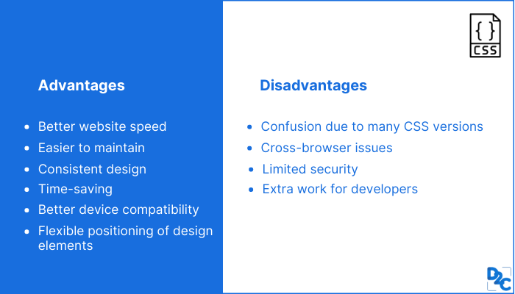

QUE) What are the disadvantages of CSS?

Ans) CSS, CSS 1 up to CSS3, result in creating of confusion among  web browsers.

* With CSS, what works with one browser might not always work with another. The web developers need to test for compatibility, running the program across multiple browsers.
* There exists a scarcity of security.
* After making the changes we need to confirm the compatibility if they appear. The similar change affects on all the browsers.
* The programing language world is complicated for non-developers and beginners. Different levels of CSS i.e. CSS, CSS 2, CSS 3 are often quite confusing.
* Browser compatibility (some styles sheet are supported and some are not).
* CSS works differently on different browsers. IE and Opera supports CSS as different logic.
* There might be cross-browser issues while using CSS.
* There are multiple levels which creates confusion for non-developers and beginners.

Eg-: 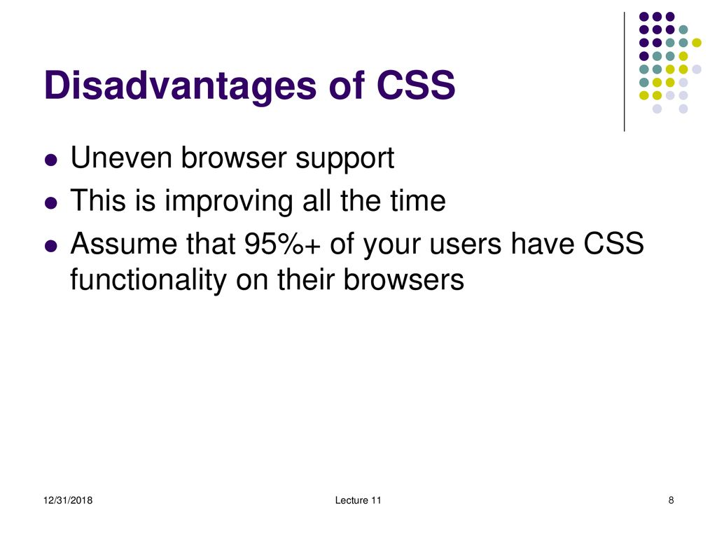

QUE) What is the difference between CSS2 and CSS3?

ANS) The biggest difference between CSS2 and CSS3 is that CSS3 is now split into different modules. Since each module makes its way through the W3C individually, there's a wider range of browser support. Make sure you test your CSS3 pages in as many browsers and operating systems as possible to ensure compatibility.

Eg-: 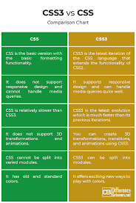

QUE) Name a few CSS style components

ANS) The components of css style are: 1)Selecter:HTML element name, id name, class name. 2)Property:It's like an attribute such as background color,font-size,position,text-align,color,border etc. 3)Values:which defines property or values allocate for properties.

Eg-: 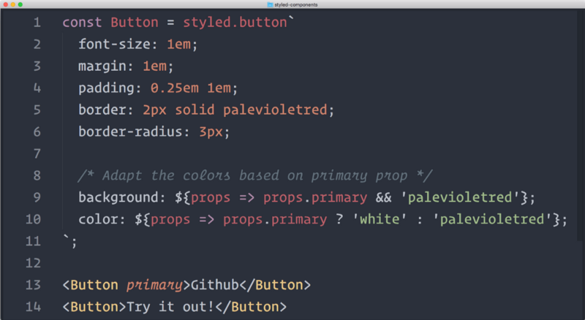

QUE) What do you understand by CSS opacity?

ANS) The opacity CSS property sets the opacity of an element. Opacity is the degree to which content behind an element is hidden, and is the opposite of transparency.

Eg-: 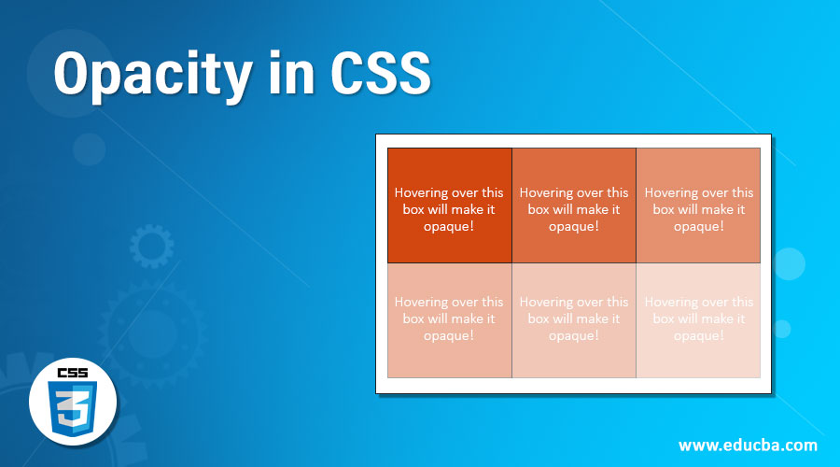

QUE) How can the background color of an element be changed?

ANS) Add a CSS class to the div you'd like to change. First, find the div in your HTML code and add a class to the opening tag. ...

* Add the new class selector to your CSS code. Next, head over to your CSS code and add your new class selector. ...
* Choose a new background color.

Eg-: 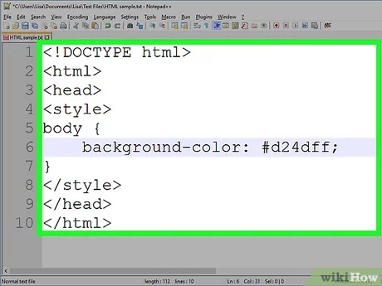

QUE) How can image repetition of the backup be controlled?

ANS) To control the repetition of an image in the background, use the background-repeat property. You can use no-repeat value for the background-repeat property if you do not want to repeat an image, in this case, the image will display only once.

QUE) What is the use of the background-position property?

ANS) The background-position property sets the starting position of a background image. Tip: By default, a background-image is placed at the top-left corner of an element, and repeated both vertically and horizontally.

Eg-: 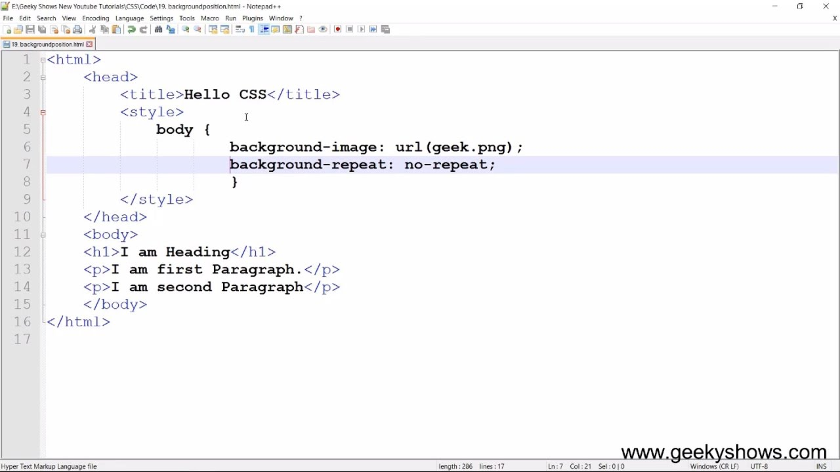

QUE) Which property controls the image scroll in the background?

ANS) The background-attachment property sets whether a background image scrolls with the rest of the page, or is fixed.

Eg-: 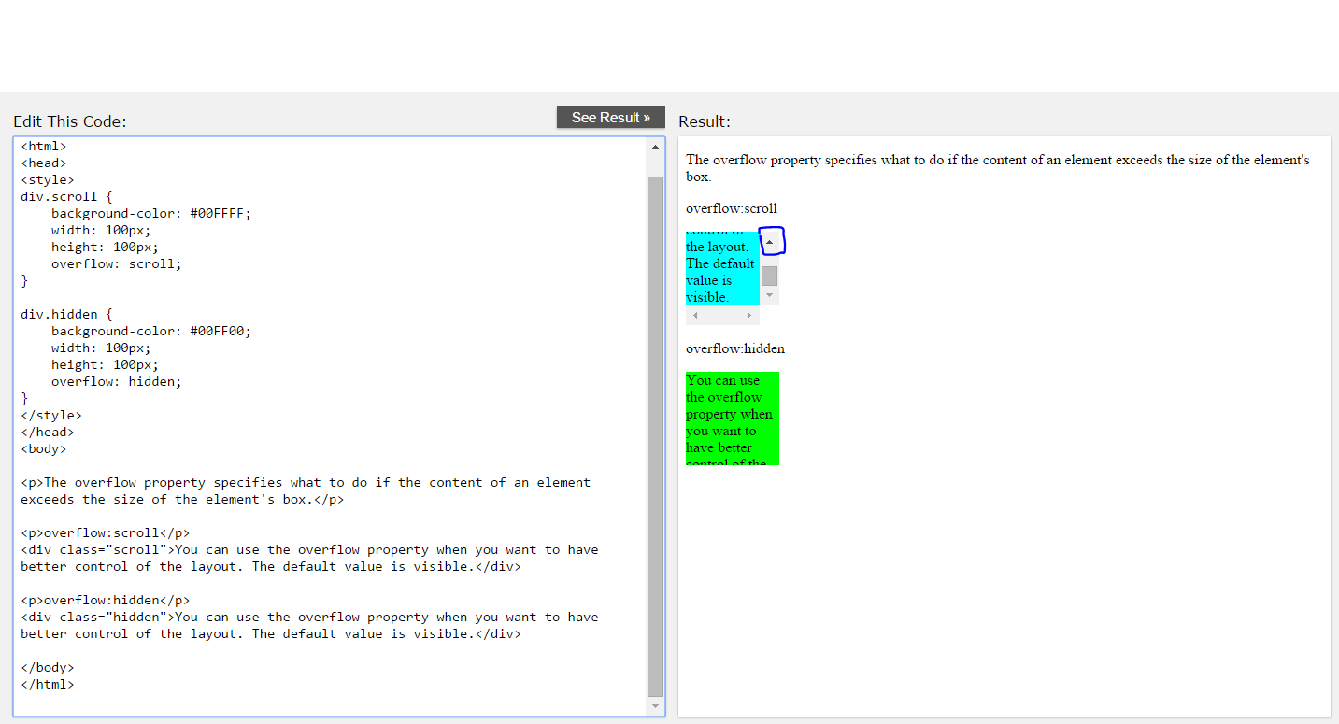

QUE) Why should background and color be used as separate properties?

ANS) There are two reasons behind this: It enhances the legibility of style sheets. The background property is a complex property in CSS, and if it is combined with color, the complexity will further increase.

Eg-: 

QUE) How to center block elements using CSS1?

ANS) With css the way to center anything that's a block level element is with the margin property. One of the values of margin is auto and by setting auto on the left and right margin our block level element will center itself.

Eg-: 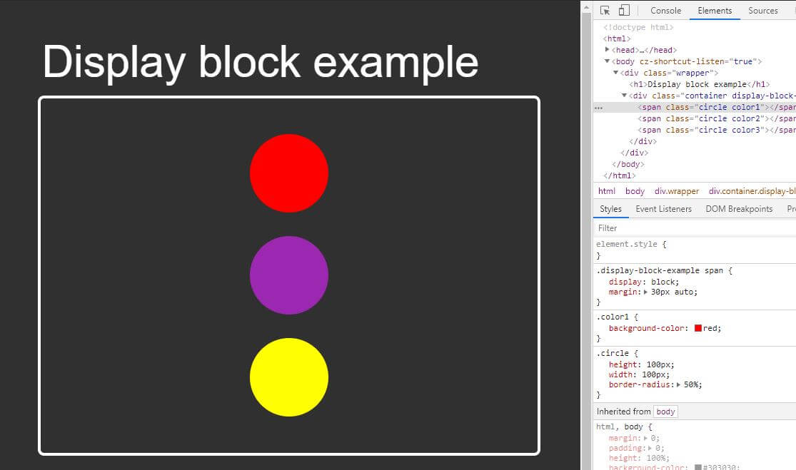

QUE) How to maintain the CSS specifications?

ANS) with the help of w3c we can maintain the css specification.

QUE) What are the ways to integrate CSS as a web page?

ANS) CSS can be added to HTML documents in 3 ways: Inline - by using the style attribute inside HTML elements. Internal - by using a <style> element in the <head> section. External - by using a <link> element to link to an external CSS file.

Eg-: 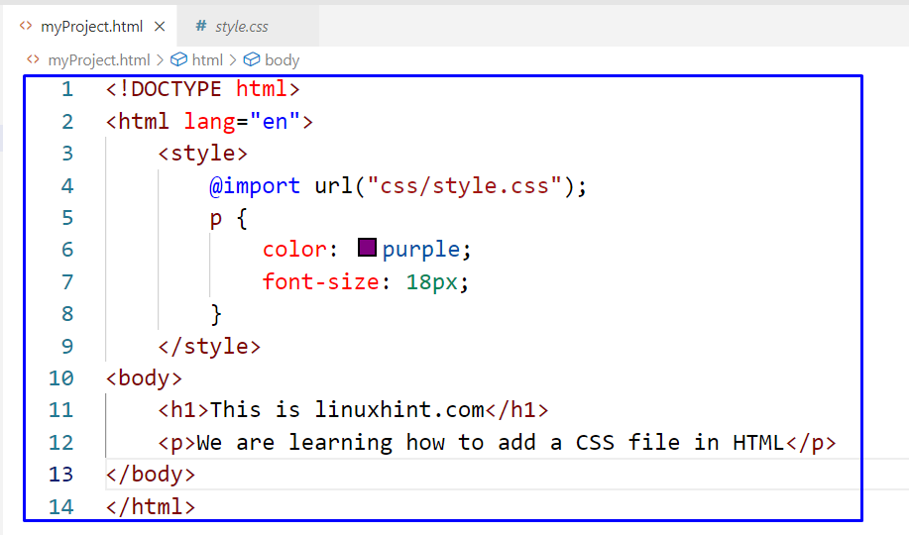

QUE) What is embedded style sheets?

ANS) Embedded Stylesheet: It allows you to define styles for a particular HTML document as a whole in one place. This is done by embedding the <style></style> tags containing the CSS properties in the head of your document.

Eg-: 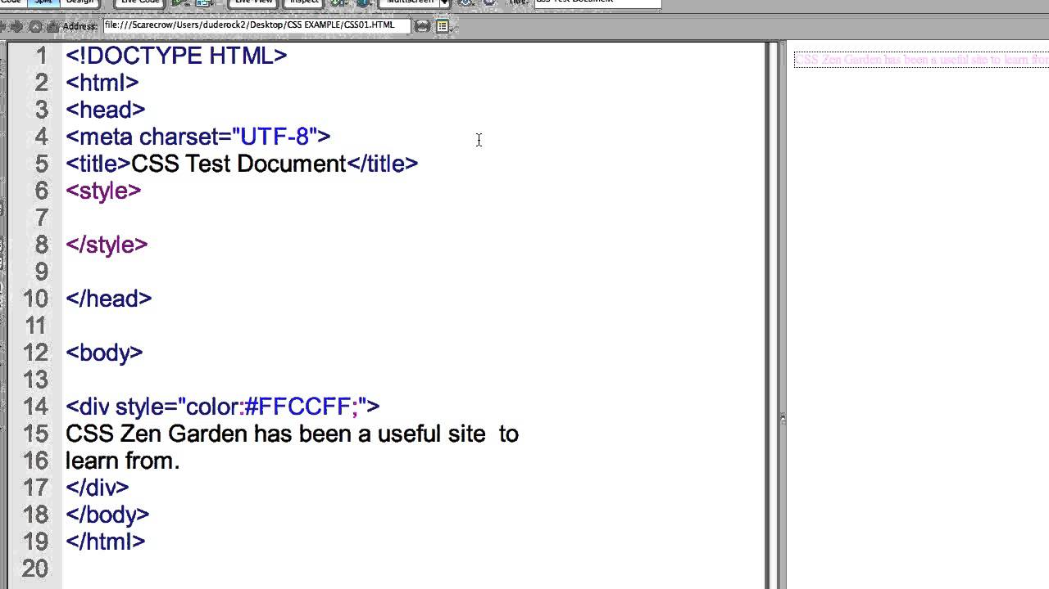

QUE) What are the external style sheets?

ANS) An external style sheet is a separate CSS file that can be accessed by creating a link within the head section of the webpage. Multiple webpages can use the same link to access the stylesheet. The link to an external style sheet is placed within the head section of the page.

QUE) What are the advantages and disadvantages of using external style sheets?

ANS) External style sheets have the following advantages over internal and inline styles:

* one change to the style sheet will change all linked pages.
* you can create classes of styles that can then be used on many different HTML elements.
* consistent look and feel across multiple web pages.

Eg-: 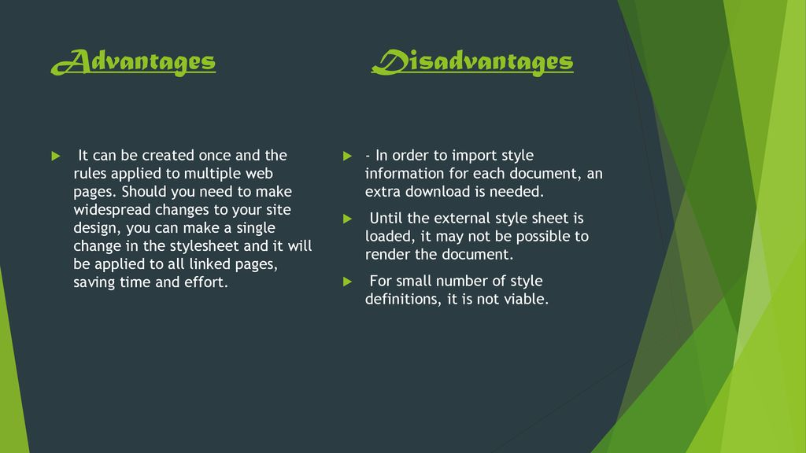

QUE) What is the meaning of the CSS selector?

ANS) CSS selectors are used to "find" (or select) the HTML elements you want to style. We can divide CSS selectors into five categories: Simple selectors (select elements based on name, id, class) Combinator selectors (select elements based on a specific relationship between them)

Eg-: 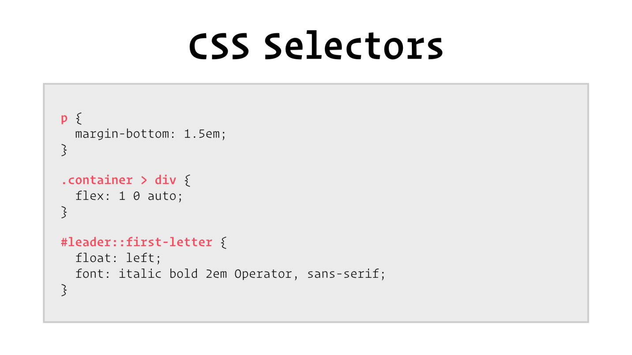

QUE) What are the media types allowed by CSS?

ANS) CSS 2.1 defines the following media groups:

* continuous or paged.
* visual, audio, speech, or tactile.
* grid (for character grid devices), or bitmap.
* interactive (for devices that allow user interaction), or static (for those that do not).
* all (includes all media types)

Eg-: 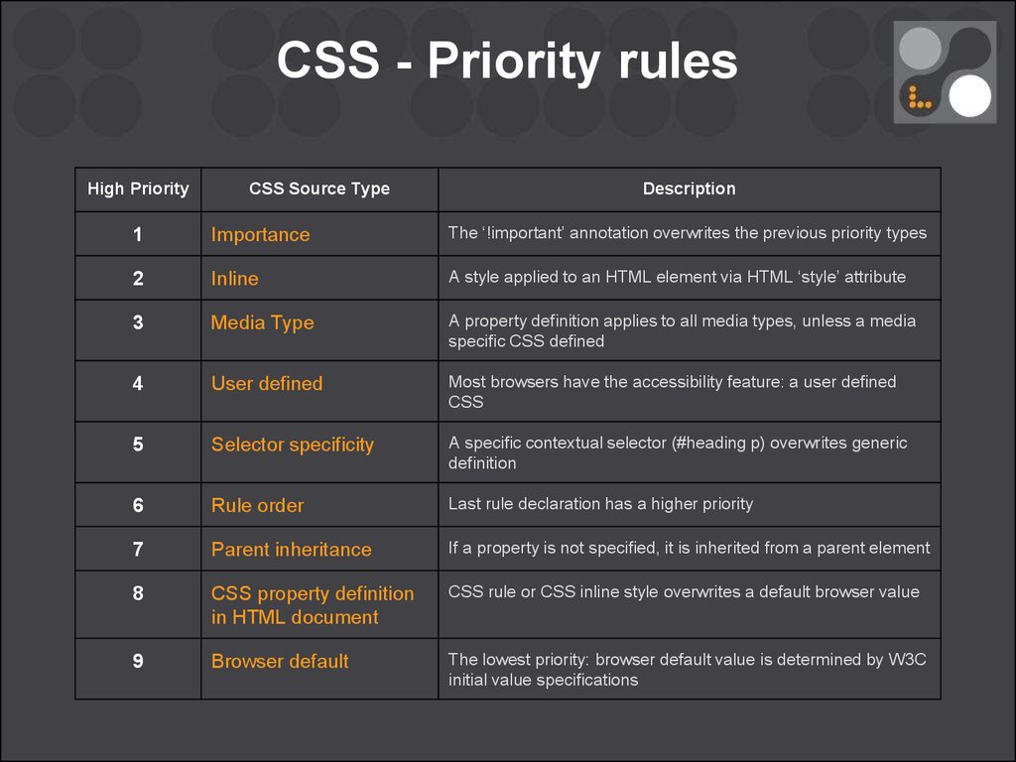

QUE) What is the rule set?

ANS) Rule sets provide the capability to achieve this broader, more holistic, view of a data source and its records by executing and evaluating multiple rules together against individual records. The output from rule sets provides a view into your data at several levels: Rule level.

Eg-: 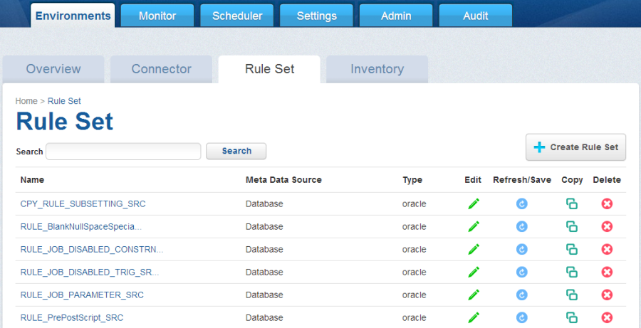

MODULE : 3 HTML 5

QUE) What are the new tags added in HTML5?

ANS)

|  |  |
| --- | --- |
| <article> | Represents an independent piece of content of a document, such as a blog entry or newspaper article |
| <aside > | Represents a piece of content that is only slightly related to the rest of the page. |
| <audio> | Defines an audio file. |
| <canvas> | This is used for rendering dynamic bitmap graphics on the fly, such as graphs or games. |
| <command> | Represents a command the user can invoke. |
| <datalist> | Together with the a new list attribute for input can be used to make comboboxes |
| <details> | Represents additional information or controls which the user can obtain on demand |
| <embed> | Defines external interactive content or plugin. |
| <figure> | Represents a piece of self-contained flow content, typically referenced as a single unit from the main flow of the document. |
| <footer> | Represents a footer for a section and can contain information about the author, copyright information, et cetera. |
| <header> | Represents a group of introductory or navigational aids. |
| <hgroup> | Represents the header of a section. |
| <keygen> | Represents control for key pair generation. |
| <mark> | Represents a run of text in one document marked or highlighted for reference purposes, due to its relevance in another context. |
| <meter> | Represents a measurement, such as disk usage. |
| <nav> | Represents a section of the document intended for navigation. |
| <output> | Represents some type of output, such as from a calculation done through scripting. |
| <progress> | Represents a completion of a task, such as downloading or when performing a series of expensive operations. |
| <ruby> | Together with <rt> and <rp> allow for marking up ruby annotations. |
| <section> | Represents a generic document or application section |
| <time> | Represents a date and/or time. |
| <video> | Defines a video file. |
| <wbr> | Represents a line break opportunity. |

New types for <input> tag

The input element's type attribute now has the following new values −

|  |  |
| --- | --- |
| **Type** | **Description** |
| color | Color selector, which could be represented by a wheel or swatch picker |
| date | Selector for calendar date |
| datetime-local | Date and time display, with no setting or indication for time zones |
| datetime | Full date and time display, including a time zone. |
| email | Input type should be an email. |
| month | Selector for a month within a given year |
| number | A field containing a numeric value only |
| range | Numeric selector within a range of values, typically visualized as a slider |
| search | Term to supply to a search engine. For example, the search bar atop a browser. |
| tel | Input type should be telephone number. |
| time | Time indicator and selector, with no time zone information |
| url | Input type should be URL type. |
| week | Selector for a week within a given year |

QUE) How to embed audio and video in a webpage?

ANS) To embed video in HTML, we use the <video> tag. It contains one or more video sources at a time using <source> tag. It supports MP4, WebM, and Ogg in all modern browsers.

Eg-: 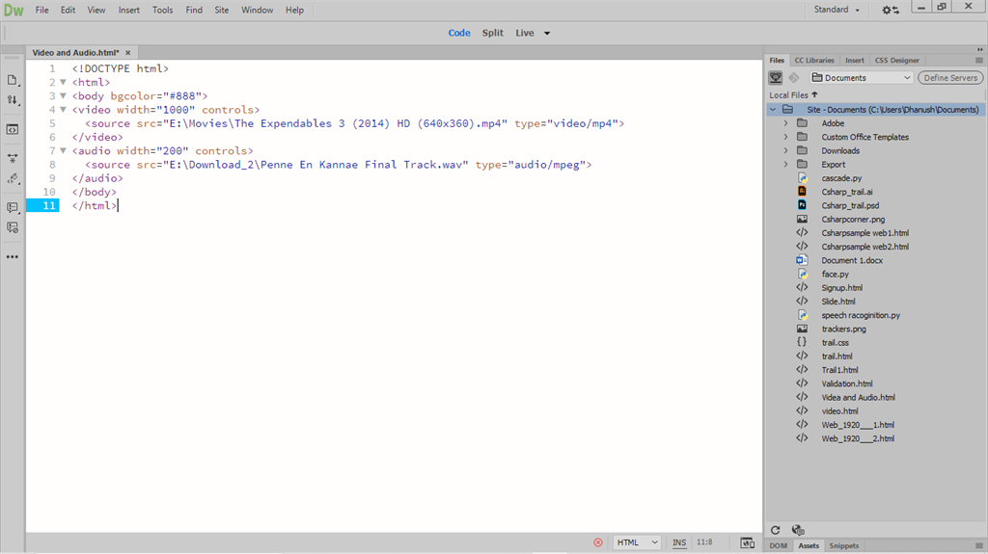

QUE) Semantic element in HTML5?

ANS) The HTML semantics refers to the tags that provide meaning to an HTML page rather than just presentation. It makes HTML more comprehensible by better defining the different sections and layout of web pages.

Eg-: 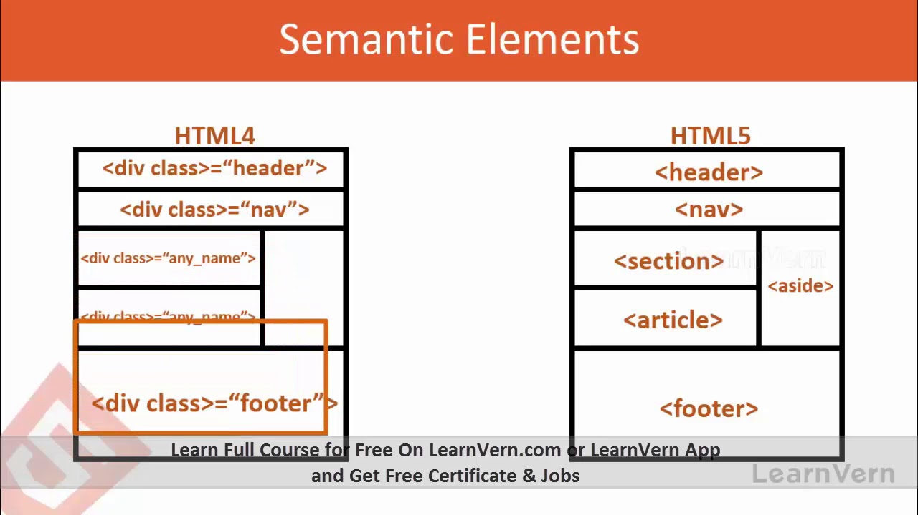

QUE) Canvas and SVG tags

ANS) The <svg> tag defines a container for SVG graphics. SVG has several methods for drawing paths, boxes, circles, text, and graphic images.

Eg-: 